**Project Planning Phase**

**Project milestone & activity**

|  |  |
| --- | --- |
| Date | 29 October 2022 |
| Team ID | PNT2022TMID14537 |
| Project Name | Gas Leakage Monitoring and Alerting System for Industries |
| Maximum Marks | 8 Marks |

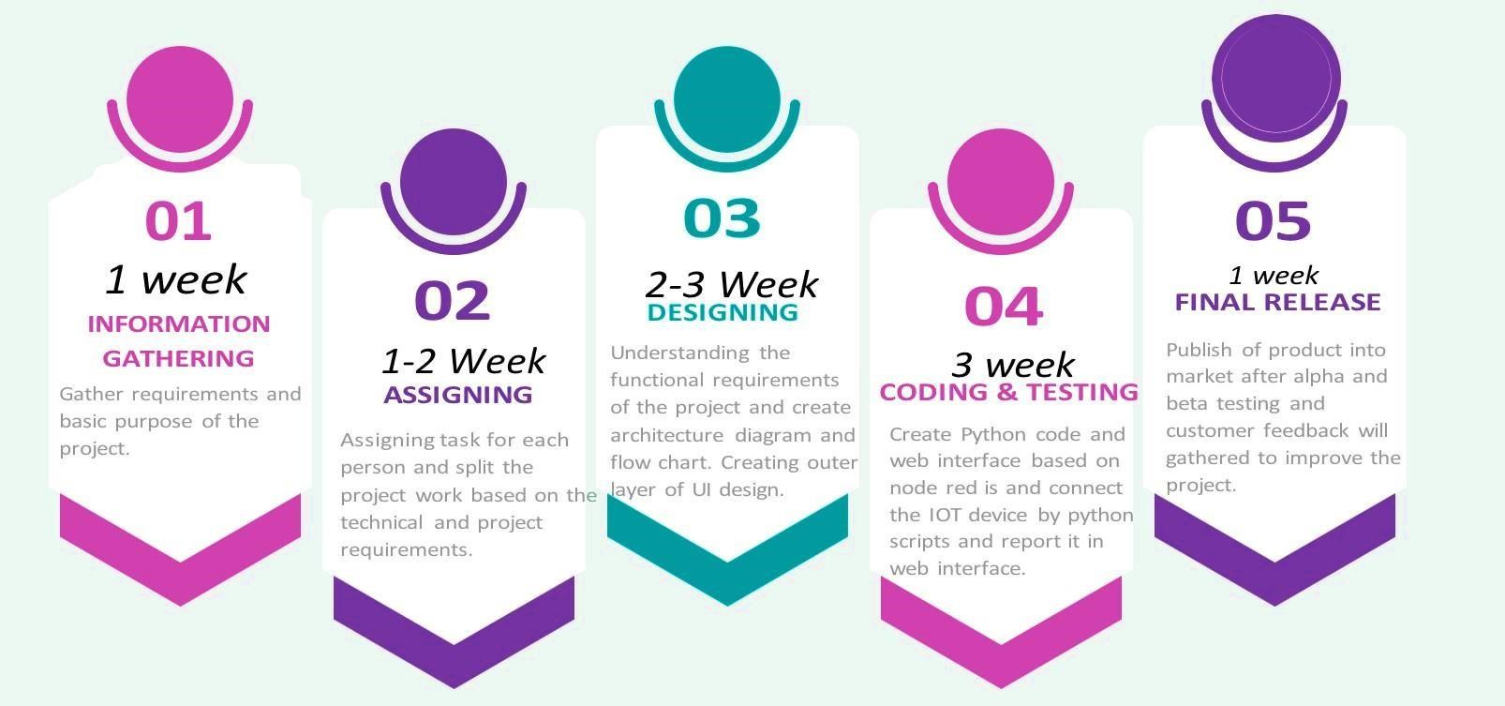

**Project**

**Milestone:**

**Activity**

**List:**

|  |  |  |  |
| --- | --- | --- | --- |
| **S.**  **No.** | **Activity Title** | **Activity Description** | **Duration** |
| **1** | **Understanding the**  **project requirement** | Assign the team members & create the repository in GitHub. Assign the task to each member and teach how to use and open access the GitHub and IBM Career Education. | 1 Week |
| **2** | **Starting of Project** | Advice student to attend classes of IBM portals create and develop a rough diagram based on the project description and gather information of IOT and IBM project. | 1 Week |
| **3** | **Attend Classes** | Team members & team lead must watch and learn from classes provided by IBM and Nalaiya Thiran and must gain access of MIT License for their project. | 1 Week |
| **4** | **Budget and scope of project** | Budget & analyze the use of IOT in the project and discuss with the team for budget prediction to predict the favorability of the customer to buy the product for efficient use of the product among the environment. | 1 Week |